**In the name of God**

**Name:mohammad ali**

Ph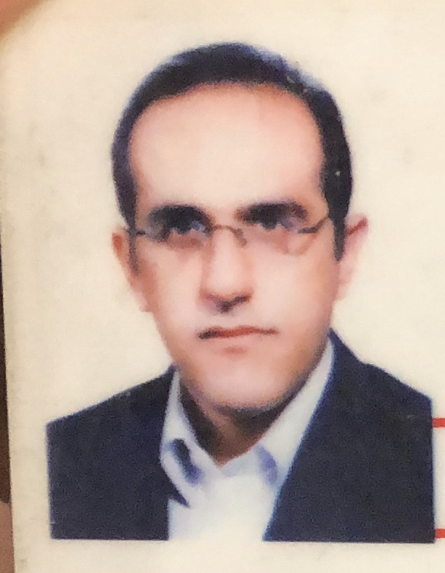oto

**Surname name: roozegar**

|  |  |
| --- | --- |
| **Contact information:** | Address: Ilam University of Medical Sciences, ….., Ilam  Tel: 0098-9183171341  Fax: 00988413337119  E-mail:roozegar48@yahoo.com |
| **Academic rank:** | Associate Professor |
| **Faculty:** | **dentistry**, Department periodontology |

**Educational history**

|  |  |  |  |  |
| --- | --- | --- | --- | --- |
| **Graduation date** | **Country** | **University** | **Degree** | **Academic field** |
| 2003 | iran | tehran | General dentist | Dentistry |
| 2009 | iran | Hamedan | MSD ( periodontology) | pathology |

**Publication**

1.in vitro Osteogenic impulse effect of Dexamethasone on periodontal ligament stem cells.

Roozegar MA1, Mohammadi TM2, Havasian MR1, Panahi J1, Hashemian A1, Amraei M3, Hoshmand B4

2. The prevalence of the localized aggressive periodontitis among 14-16 years students at Ilam, Iran

Mohammad Ali Roozegar, Zeinab Mohamadi, Amirreza Hashemian

3.Knowledge of physical education teachers’ toward tooth avulsion in Tehran, Iran

Jafar Panahi MSc1, Mohammad Reza Havasian MSc1, Mohammad Ali Roozegar DMD, MS2

4. Study of the inhibitory effect of Quercus Coccifera's aqueous extract on Staphylococcus aureus and Pseudomonas aeruginosa In vitro.

Judaki A1, Panahi J2, Havasian MR2, Tajbakhsh P2, Roozegar MA

5. Improvement of periodontal parameters in untreated site after periodontal surgery at adjacent sites

Mohammad Ali rouzgar*,Amir reza hashemian, mohamad reza havasian ,jafar panahi and janet moradi haghgoo

6. IN VITRO INHIBITORY EFFECT OF ALCOHOLIC AND AQUEOUS EXTRACT OF UMBILICUS INTERMEDIUS BOISS (NAFE VENUS) ON STAPHYLOCOCCUS AUREUS AND PSEUDOMONAS AERUGINOSA

• Mohamad Ali Roozegar, Zeynab Pournazari, Mohamad Reza Nazari, Mohamad Reza Havasian, Jafar Panahi, Iraj Pakzad

7. Studying the inhibitory effect of Alcoholic extract of inner Stratum of Oak Fruit (jaft) and hydro alcoholic extract of Summer bulb on Acinetobacter in vitro

Roozegar Mohhamad Ali, Panahi Jafar, Reza Havasian Mohamad, Pakzad Iraj

8. ilam lipid and glucouse study: A cross-sectional epidemiologic study mohamad reza havasian, jafar panahi, Mohammad Ali rouzgar

9.in vitro study of low _level laser irritationonosteoblastic differention of human periodontal ligament stem cells

Mohammadali roozegar,salar Bakhtiari, jafar Panahi

10. The in vitro study on anti-microbial activity of aqueous extracts of internal shell of walnut against some oral microbial strains

Mohammad Ali Rouzegar 1,2, Amirreza Hashemian 1, Rasoul Yousefi 2, Jafar Panahi3, Mohamad Reza Havasian3, Behzad Houshmand

11. Comparative Evaluation of Density of Mast Cells and Microvessel in between Oral and Cutaneous Squamous Cell Carcinoma Khadijeh Abdal1, Mohammad Ali Roozegar2, Parya Emamverdizadeh3, Samira Mostafazadeh4

12. Evaluation of histopathologic changes pulp and follicle tissues in third molar impacted in patient under 40 years of age

KhadijehAbdal 1 ,faezehabdalbeygi 2 , MarziehDarvishi

13. The Effect of 1.2mg Simvastatin Mouthwash on the Level of Interleukin-6 in Patients with Chronic Periodontitis

Mohammad-Ali Roozegar 1 , Zeinab Abdi 2 , Somayeh Matin 3* , Ali khorshidi 4 , Mohammad azizian

14. . Investigation of Oral Health Status (DMFT-index) among 3-6 Years Old Children in Ilam (Western Iran), 2015

Maryam Esmaeilikia1, Zeinab Ghazanfari1,2, Mohammad-Sadegh Abedzadeh?, Elahe Gholami-Parizad1*, Mohammad-Ali Roozegar3

15.evaluation of DMFT and CPITN indices among user of various drugs

Khadijeabdal-rezavalizadeh-aref Nazari-mohammadali roozegar

.

**Course teaching**

* I am teaching From 2009 in Ilam university of medical sciences .

**Honors**

* Elected twice as perfect master of Ilamuniversity of medical sciences (2014 -2018).

**Experiences**

1. Assistant Professor , Department of periodontology Ilam University of Medical Sciences, 2009-00
2. Head of dentistry school of Ilam University of Medical Sciences, 2011-2015
3. Manager Research Committee faculty of dentistry, Ilam University of Medical Sciences, 2009-00
4. Manager research academy faculty of dentistry, Ilam University of Medical Sciences,

2009-00

1. Established school of oral hygine in sarableh(2009-2012)

**Memberships**

* Member of the research councilfaculty of dentistry, Ilam University of Medical Sciences, 2009-00
* Member of the finance committeefaculty of dentistry, Ilam University of Medical Sciences, 2011-00
* Member of the engage scienfificcommitteeIlam University of Medical Sciences, 2009-00

**Research Interests:**

periodontology – dentistry